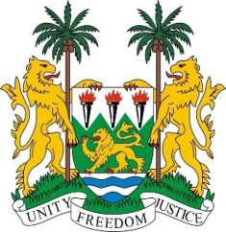
SIERRA LEONE

27th Session of the UPR

INDONESIA

3 May 2017

Mr President,

Sierra Leone welcomes the distinguished delegation from Indonesia to this review cycle and thanks them for their presentation.

My delegation notes that in the five years since its last review, Indonesia has made good progress in its human rights promotion – as seen in the ratification of three international instruments and the inclusion of the Sustainable Development Goals in its 2015-2019 Medium-Term Strategic Plan. Also noteworthy is the 12-year compulsory and free education programme and the National Strategy on the Elimination of Violence against Children (2016-2020). My delegation notes the financial contributions of Indonesia to the OHCHR.

However, my delegation encourages Indonesia to make greater efforts to further ensure the protection of human rights of women, children and minority groups.

Recommendations:

- Ratify the ICPPED and the Optional Protocol of the CEDAW.
- Modify the Criminal Procedure Code to ensure better protection for women, and thoroughly investigate allegations of violence or abuse perpetuated against children while in detention.
- Ensure that Komnas Perempuan is in conformity with the Paris Principles.
- Enact and enforce legislation to raise the legal age of marriage for boys and girls to 18.

Finally, Sierra Leone wishes Indonesia a successful review.

Thank you, Mr President.

